
Guidelines for
Group Leaders

Contents

Page
1 Starting a Group 3

2 Getting a Group Going 3

3 First Meeting 4

4 Running a Group 4

5 Group Member Charges 5

6 Payment of Tutors 6

7 Setting up the Room & Refreshments 7

8 Record Keeping 7

9 Keeping Members Informed 8-9

10 Groups that are Full 10

11 Insurance 10

12 Accidents, Illness, Non-attendance 11

13 Access to Groups 11

14 Sources of Support 12

15 Beacon help 13-15

Registered Charity 1113103 April V4.1 2025
1 Starting a Group

• The purpose of the u3a is to provide opportunities to continue learning and to take part in activities, through the sharing of knowledge and experience of members. Interest and activity groups are formed according to the wishes and skills of members.

• The Group Leaders play a vital role in providing an appropriate environment for learning and enjoyment.

• A wide range of groups can be found in our u3a, and a variety of approaches to learning are used by our Group Leaders. These may include formal talks, organised and structured programmes of learning, and occasional educational outings or fieldwork trips. Note that our activities are not accredited by any academic organisation.

2 Getting a Group going
• If you have an idea for a new group or you hear of someone who has, there may be other members who would like to join in to explore the subject. In the first instance contact the Group Co-ordinator who will help you work out if your idea is viable.

• The time and location of a new group is important, so consult the Group Co-ordinator about possibilities. Groups can meet with any frequency, but the availability of a suitable venue is key. You must be a u3a member to be a Group Leader otherwise you are not covered by u3a insurance.

3 First Meeting
• If you feel that you would like help getting your group started, do contact the Group Co-ordinator, who will assist you. Ensure that the members of the group agree about how the group will work. As a Group Leader you need to know what you can reasonably offer in terms of time and commitment.

• Decide how much participation is expected from members, how often the group will meet and what will be the size of the group? Will the group leader lead all the sessions and how should the sessions be structured?

- How much will the members pay? This will be influenced by venue charges, which may include refreshments costs. This may evolve with time.

• Try to find out what knowledge and experience exists in the group. A mix of methods and styles is thought to work well for most members. You might also want to have a look at the range of publications and other resources available from the Third Age Trust (TAT).

4 Running a Group
Booking a Room
- Please note that financial assistance is available for the first 3 sessions, if required. The Treasurer should be kept informed of the group venues, so that hire charges for the rooms can be paid where necessary.

- Some smaller groups hold meetings in member’s homes as appropriate to the group concerned. If you need to change or cancel a room booking you must inform the Group Co-ordinator and the Treasurer, so that hire charges can be adjusted, if appropriate. The length of sessions and the frequency of meetings are up to you but most sessions run for 1.5 or 2 hours, and the rooms need to be booked accordingly.

5 Group Member Charges
- All members of your group should pay attendance fees at each meeting, or at a frequency you decide. As the group leader, you have the choice to contribute to fees or not. Do whatever suits you and your group. You need to keep a record of those who have paid and ensure that all members pay the same amount.

- The amount to be paid should cover the rent of the room and the cost of refreshments. Members must pay the fee whether or not they have refreshments in order to cover the room rental.

- Costs of refreshments and any other expenses, such as postage, envelopes, paper and similar should be deducted from the amount of money collected from the members. You should not be out of pocket by being a group leader.

• Provide a form of receipt if you can, and then get the money you have collected to the treasurer. Contact the Treasurer and transfer the money collected on a regular basis.

- Any monies passed to the treasurer must be accompanied by a brief summary which lists fees collected and any expenses recovered or retained.

• Group Leaders should periodically review the group fees, particularly initially, in order to ensure that the running costs are covered or a large surplus is avoided.
Note that Group payments are made to Lloyds Account and Membership payments to the Natwest account. Contact the Treasurer for the bank details.

- All groups must recover their costs from group member’s payments, so that the group operates on a break even basis. In cases where the group meets in a member’s home, and if there are no other costs incurred, no member’s fees are required.

Joint Transport
• Where transport is in shared cars, passengers are expected to contribute to the driver’s costs.

Social Events
• Social events such as concert visits, trips or lunches should be self-financing. If planning to organise an event of this type for the first time please contact a committee member or the Treasurer for advice.

6 Payment of Tutors

• Payment of tutors is generally not done in u3a, due to insurance requirements. One-off visiting speakers can be treated differently but must be financed by the group and must be registered as self-employed; holding the appropriate insurance cover. This must be agreed with the Treasurer beforehand.

7 Setting up the Room and Refreshments

• You should ask members of your group to help with setting up the room and with refreshments. Also you can ask someone in the group to help with the collection of fees and keeping records of who has paid.

8 Record Keeping

• You must keep a register of members attending your sessions. This is for Health and Safety purposes in case of accident or emergency and is required for insurance purposes.

• This can be done by members simply writing their name in an exercise book as they enter the room. Ask a member of the group to supervise this while you are getting ready to lead the group.

- Also, you need to check, or get someone else in your group to check, that all those attending are members of the u3a for insurance purposes. This should be done by the end of February each year, and for any new members joining your group. Members, who have not renewed their membership, will be listed in red on Beacon.

• If anyone attending is not a member, then you and they are not covered by u3a insurance. You can check membership from the member’s page on Beacon. Keep a membership form with you so that new members can join at the group. Non-members are permitted to attend one meeting only

• Leaders of walks or outings should also make a list of the names of those in the group at the start of the walk or outing in case of accident or emergency. Walkers can write their name on a sheet or exercise book pinned to a board at the start of the walk.

9 Keeping Members Informed

Newsletter
- Each month details of your group, venue, dates and times of meeting will appear in the Monthly Newsletter which is issued to all members. Please ensure that the Newsletter coordinator has all the correct details of your meetings, including any occasions when you have to change meeting dates and times.

- You may also wish to send a short description of any coming topics or events in your group to the Newsletter coordinator for inclusion in the next Newsletter. You can also report activities which have taken place and will be of interest to other members.

Website
- Information on your group will also appear on the Northwich u3a website as this is the first point of contact for most new members. Please check that the information on the website is correct. If your group is full you should say so, but also when there are vacancies please say that your group welcomes new members.

Beacon u3a System
• When you group is established on Beacon, use it to contact group members, by group or individual mail. The system ensures that the requirements of GDPR are met.

Putting your Group on to Beacon
• Contact the Membership Secretary to have your group added to Beacon, A username and initial password will be supplied to you. Then go to www.u3abeacon.org.uk, and select Northwich, from the dropdown list. Enter the username and password provided by Member ship Secretary. See section 15 for more help with Beacon.

Data Protection
- Members should not be given contact details of other members without that member’s written permission. All such requests for information should be passed to a Committee member who can supply information but only in case of an emergency.

10 Groups that are full
• If your group is full, please contact the Group Co-ordinator, so that the possibility of forming an additional group or finding a new venue can be investigated. Keep a list of members who wish to join, when space is available.

- If a waiting list is in place for your group, and the number of members has exceeded the maximum number set, they will be listed in your group membership list, with a date when they were placed on the waiting list. When capacity becomes available, in the group’s members list, there is an option to add them to the group.
11 Insurance

Public Liability
• As a member of the Third Age Trust, Northwich u3a Group Leaders and members are covered by public and products insurance. Individual members who think they may be at additional risk should check the cover provided by their own insurance policies.

• Educational trips (not holidays) are covered. Arrangements must be approved and financial details established, Contact the Treasurer or a Committee member for approval and before making financial commitments for group outings.
• If a non-member comes to your group, be welcoming but explain that they must become a member of Northwich u3a to attend again in order to be insured.

12 Accidents, Illness, Non-Attendance in Groups

• If you or a member of your group has an accident, incurred during group activities, please complete an incident form, available from the Group Co-ordinator or the Secretary, and ensure that the Secretary receives a copy of the report.

• Should a member of your group not attend for three months, without providing an explanation, please contact them and see if they wish to continue with the group. If they are ill or bereaved you may wish to send a card from your group.

• When you consider that a member is no longer interested in your group, please see that they are removed and that the website is kept up to date by welcoming new members If you have vacancies in your group please inform the Group Coordinator.

• Should you have any problems with members or any other aspect of your group please contact the Group Co-ordinator or a Committee member as soon as possible and ask for assistance.

13 Access to Groups

- Access to groups in Northwich u3a is open to all its members, provided that space is available within the limits of the room size the availability of equipment and resources. Group Leaders have to consider the welfare of the group, including what is a manageable and safe group size, for the activities undertaken.

- Members wishing to join a group should be given sufficient information to enable them to make an informed choice as to whether they wish to participate. The decision is then theirs. This is important if the group includes a physical activity. Members should be reminded that they undertake such activities at their own risk.

- Should a member, who is to be accompanied by a carer, wish to join your group, you should explain to both parties the nature of the group’s activities. Together you should try to identify any particular hazards that might affect the cared-for member. It may be possible to find ways to mitigate such risks to the extent that both the carer and cared-for want to join your group. In the event that you consider mitigation of particular hazards is not possible, the member and carer should be advised to consider the membership of a more appropriate group..

• Make sure that the description of your group’s activities indicates the initial level of achievement a member requires to fully enjoy participation. For example, in language groups, beginners, or improvers, in walking groups distances maybe duration of the walks.

14 Sources of Support

North West Region
- The North West Region has contacts and resources to assist you in the running of your group. Their web-site provides information and additional backing for local networks to ensure active support for Group Leaders. In addition the region often has study days, information exchange meetings, and training days.

Third Age Trust – u3a Resource Centre
• The Third Age Trust is the national body for all U3As and this has developed considerable expertise in supporting u3as in their learning activities.Contact the Resource Centre at the Third age Trust: Email:resource.centre@u3a.org.uk they have a range of materials available for u3a groups to borrow free of charge, except for the cost of return postage, which include, CDs and DVDs.

u3a matters
- A number of u3a Subject advisers are available at the Third Age Trust. Their contact details can be found in each issue of the u3a matters which you receive as a u3a member. Each issue has a subject focus, which includes study days, online courses and information, also available on the national web-site.

15 Help with Beacon

- Now that you are a Northwich u3a Group Leader, you need to manage your Group. You will need a logon to the Northwich u3aAdministration facility, where you will be provided with a username, password, and a link to logon to the portal known as Beacon. Initially the group will be created by the Northwich u3a Group Coordinator and you will have been added to the group, as a Group Leader. The first time that you logon, you will be forced to change your
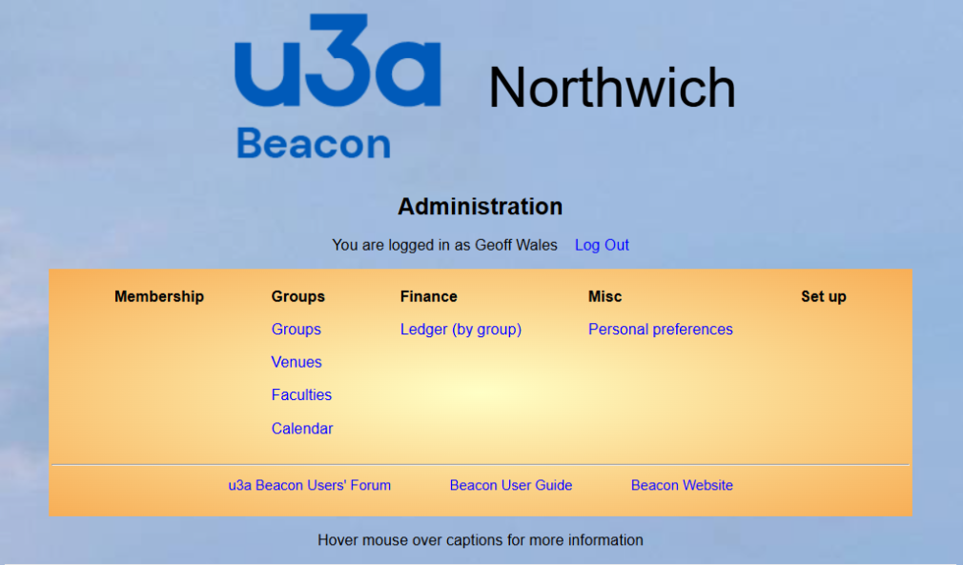
- Password Fig 1

- After successfully logging on, you should see Fig 1. On this screen, see various links, such as ‘Group’; use this link and others in dealing with your group

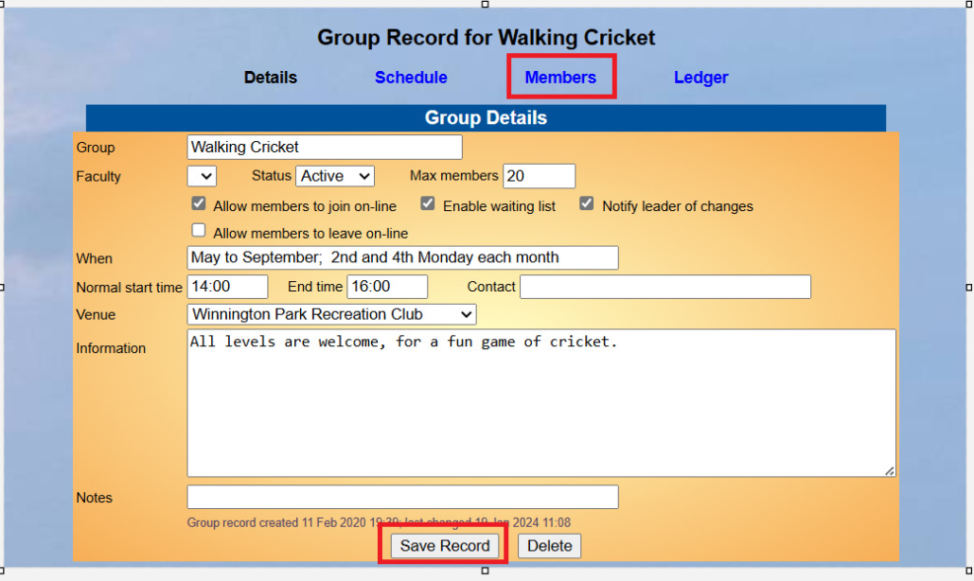
- The next screen has all the details required when your group has been set up on Beacon Name of the Group; Do you have a limit of the number of members?; When and where does it meet? Try to pick a recurring day and week of the month Select a date and time that suits you, as the Group Leader.

- One option on this screen is ‘Waiting List’. When ticked, and the maximum number of members have been reached, additional members will be placed on a waiting list with the date they were added

- When capacity becomes available, add them to the group using the option displayed next to the added date on the waiting list. Note as stated previously, sending a mail to the group, will include those waiting, unless deselected

Next is a new group Test See Fig 3
- There are no members in this group (yet).
To add a member use the members link and the tick boxes, and then the add button. Note; If you select a member, and it is added to the group, and is listed in red, then the member needs to pay annual membership fees.

- Finally note the final column where members on the waiting list are still listed by default. See the option above the ‘Group member’s line, a tick box to include members on the waiting list. If you have any, untick this box, and the members waiting won’t be displayed. Unfortunately, this needs to be unticked on each occasion.

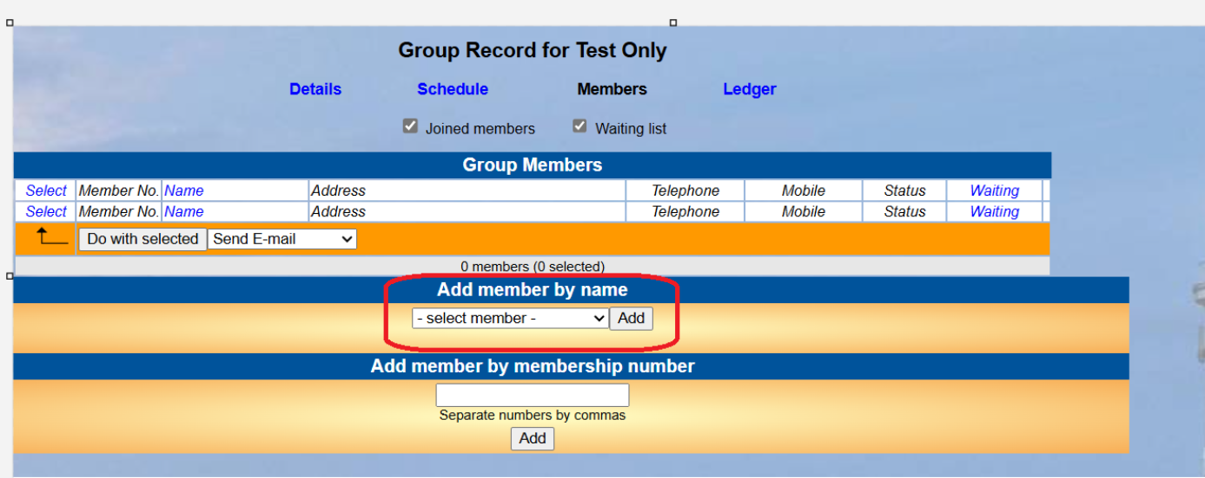
- Your group is used by you, to send an email to all the members of the group. The ‘select ‘option displayed at the top/bottom of the first column, provides several options, such as select ‘All’ To try this select ‘Select’, Select All. Note the box to do with selected, such as ‘Send an email’. This will display a screen which you can use to send mails to your group or to other member

Fig 3

